**Name**: Karthikeyan K R

**Date**: 08-01-2024

**Topic**: Creation of Repo in Azure DevOps

**Type**: Daily Assignment

**Step-1:** Login into your Azure account and go to the Azure DevOps Organizations Service then click My Azure DevOps Organizations

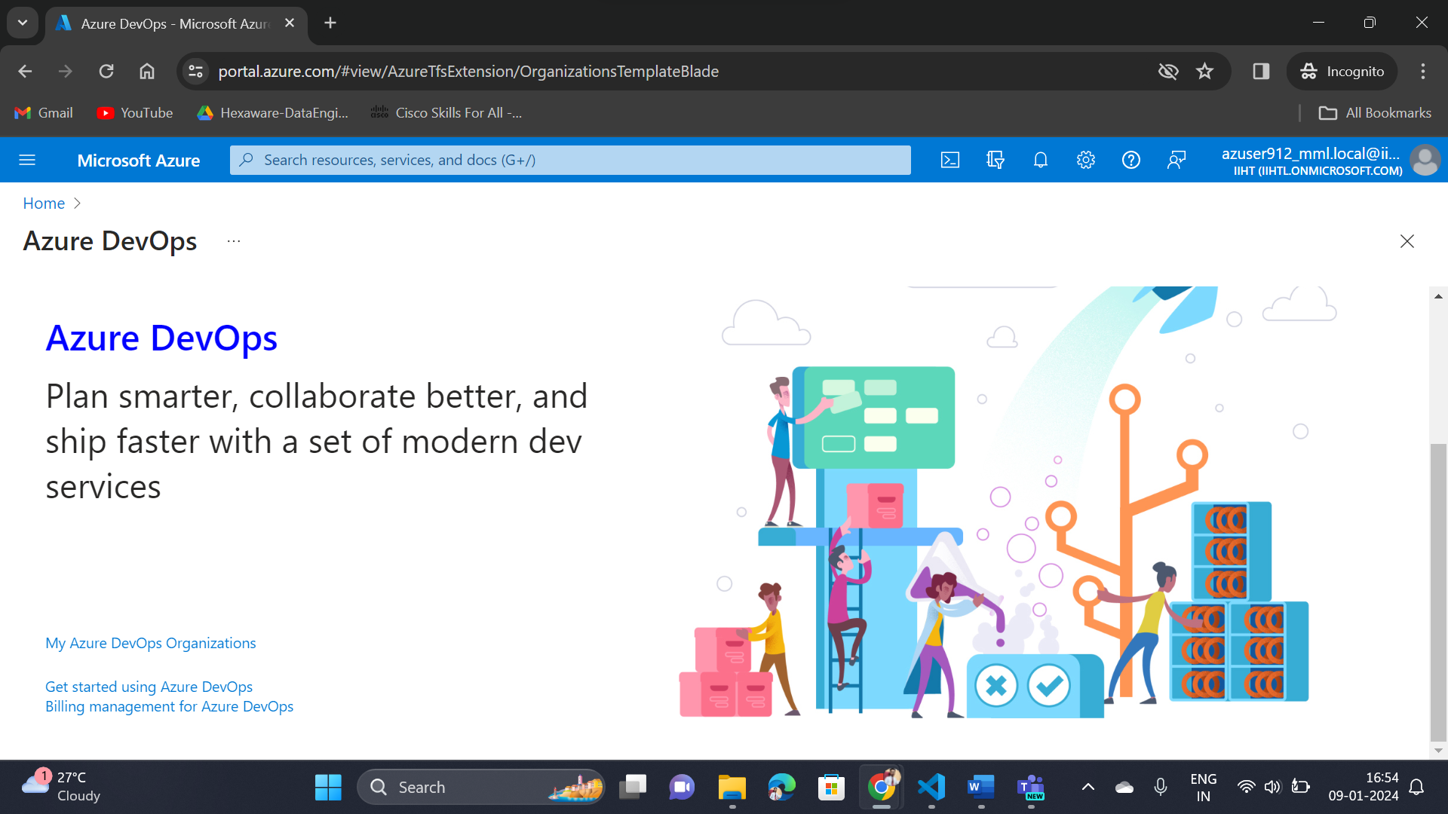

**Step-2:** Enter your Details and click Continue

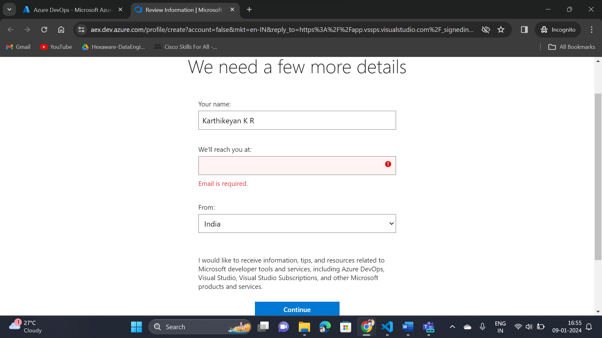

**Step-3:** Create a new organization

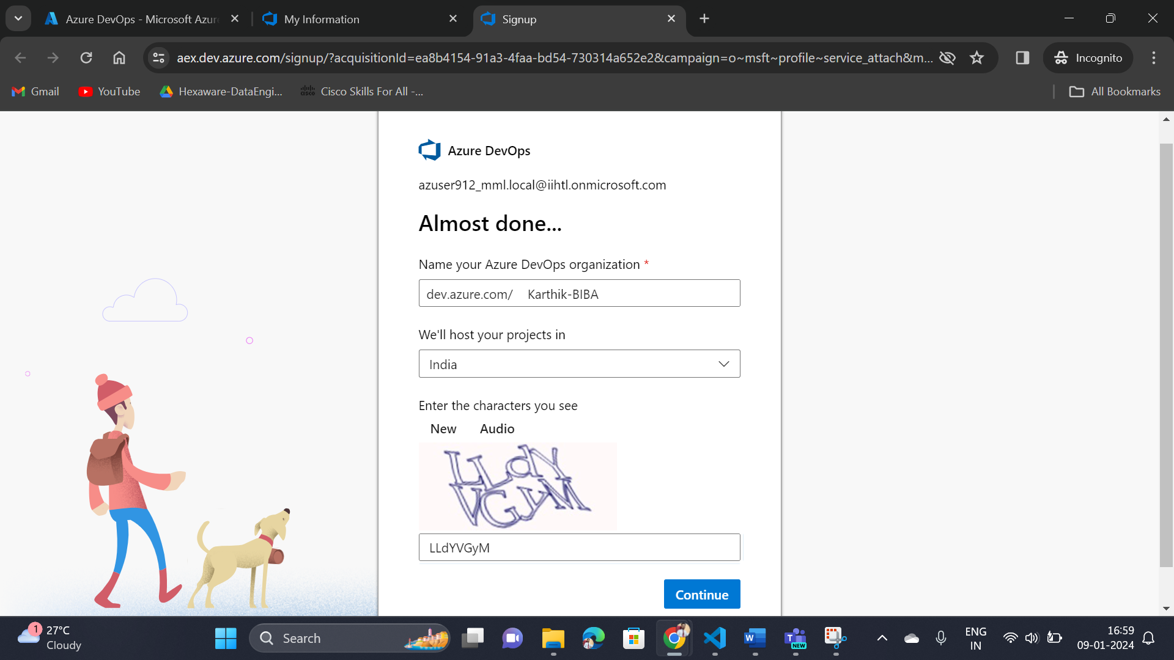

**Step-4:** Create a new project

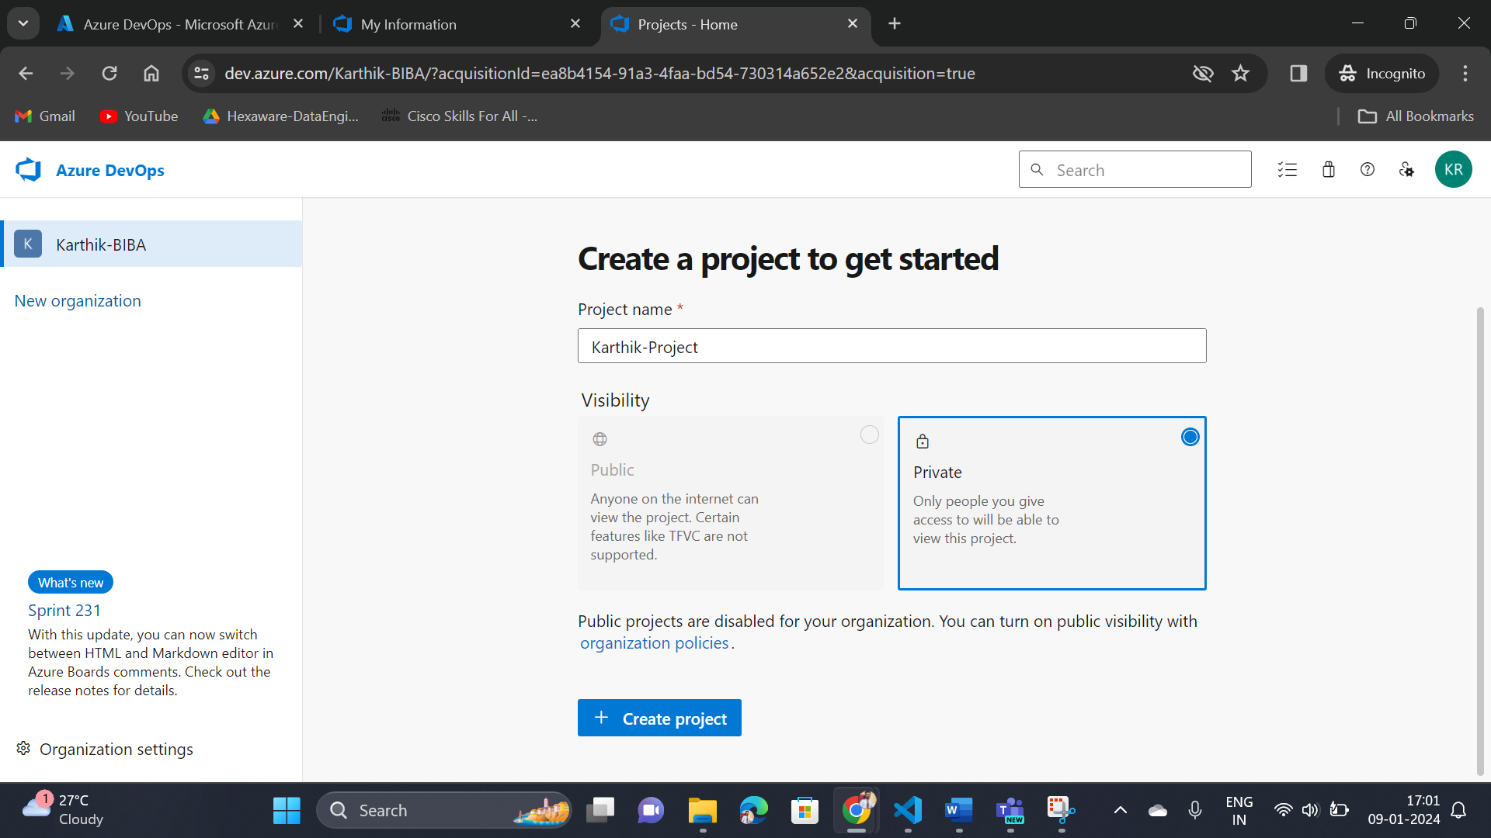

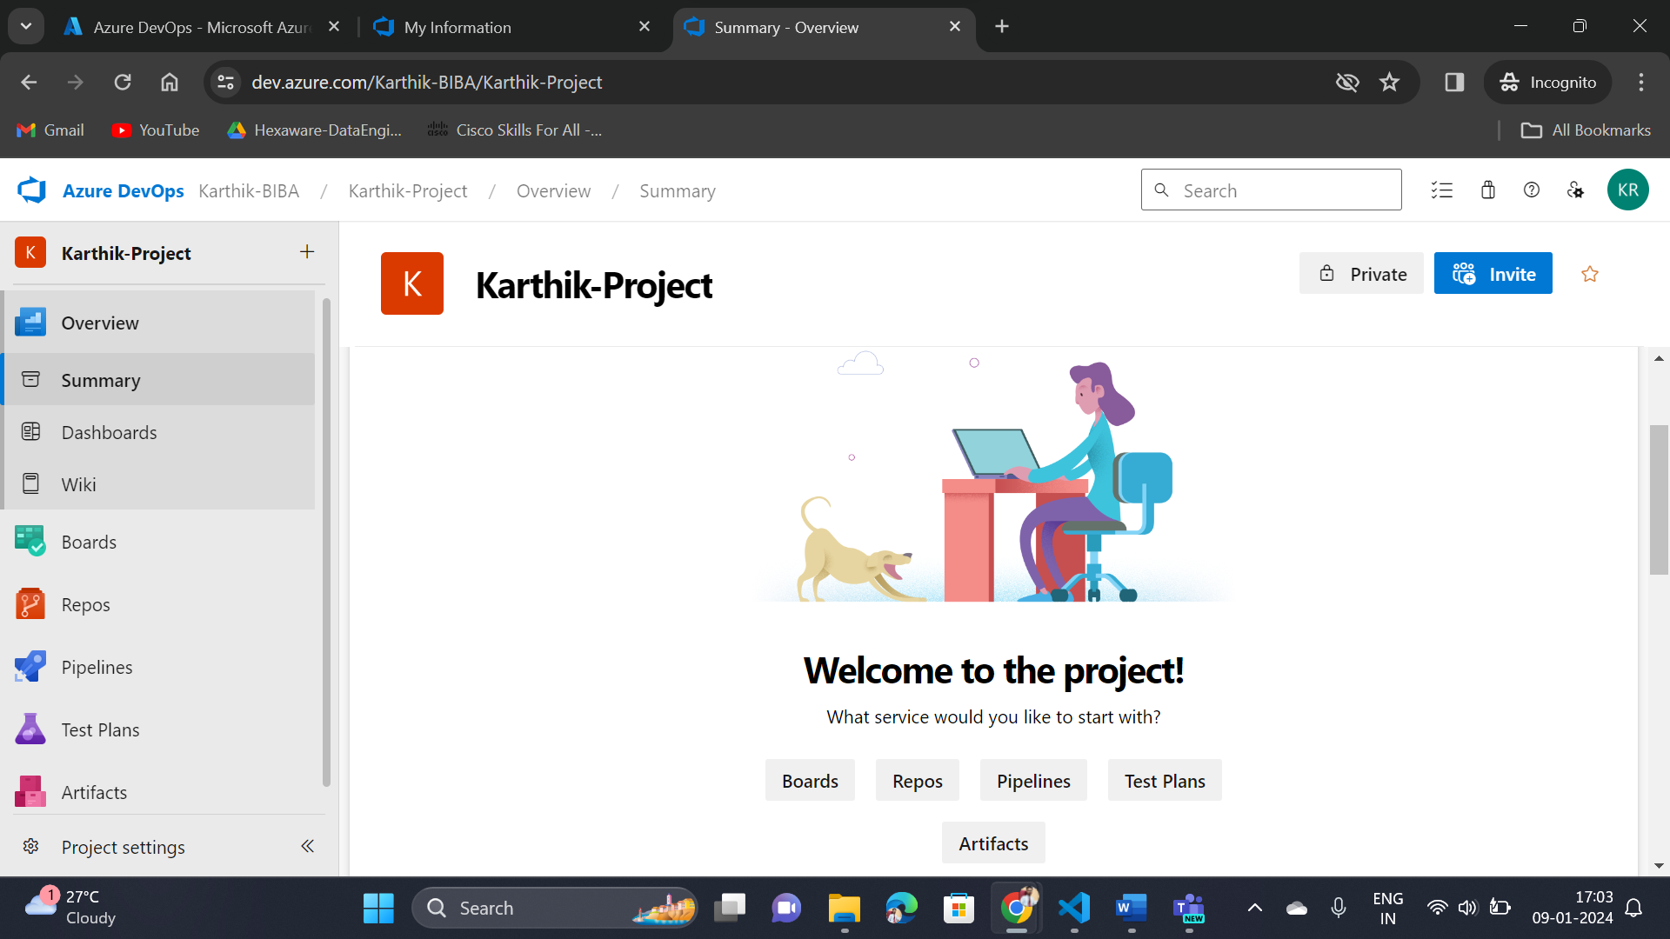

**Step-5:** Create a new repo

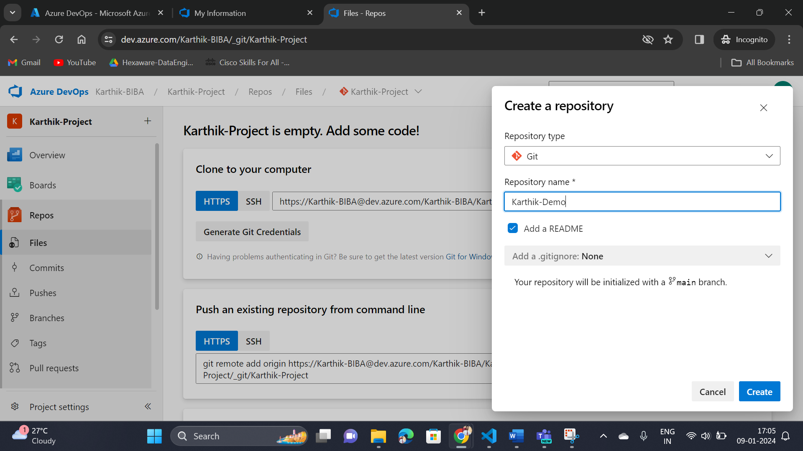

**Step-6:** Now select the clone option

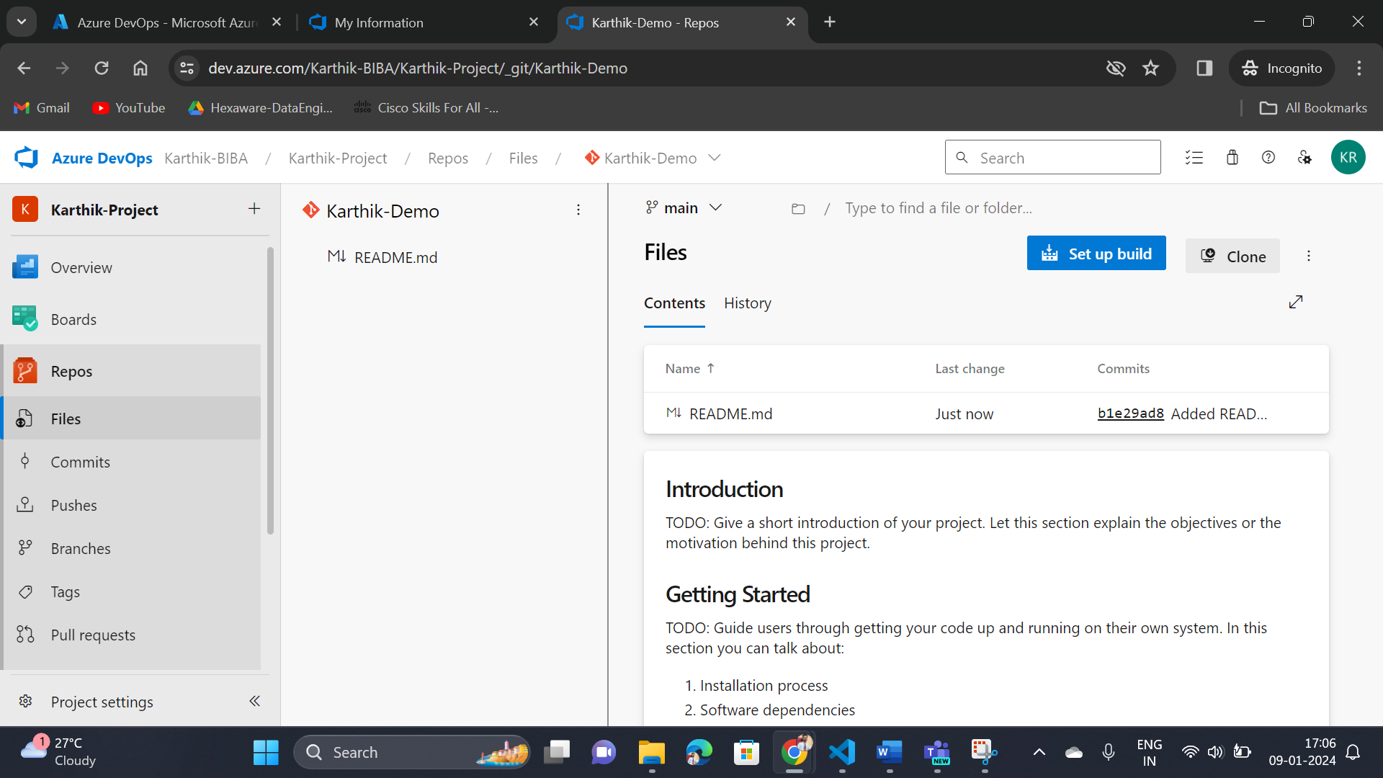

**Step-7:** Now select the clone in vs-code option

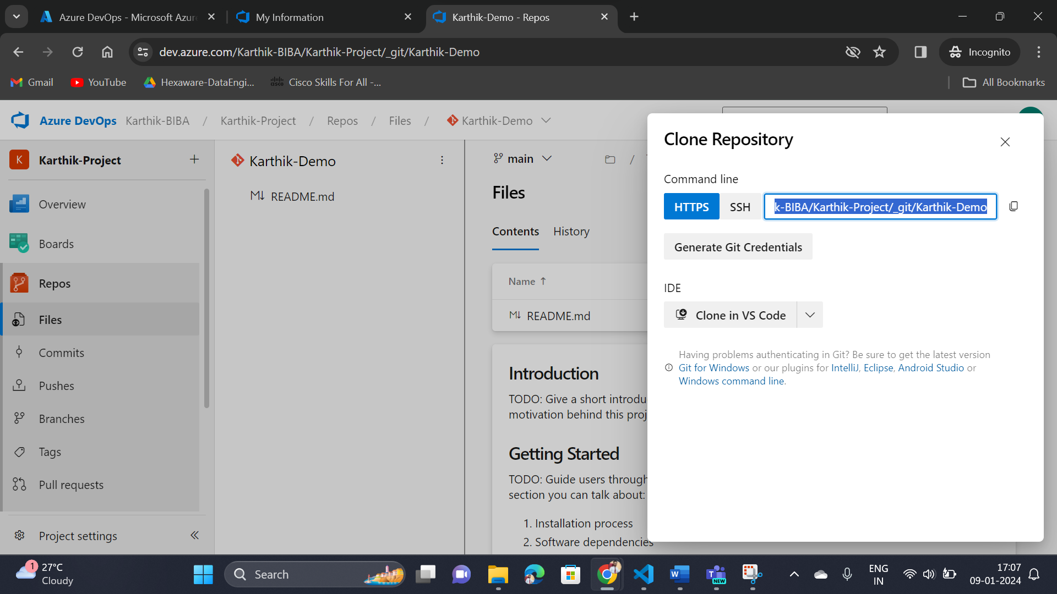

**Step-8:** You can see the cloned version on vs code studio

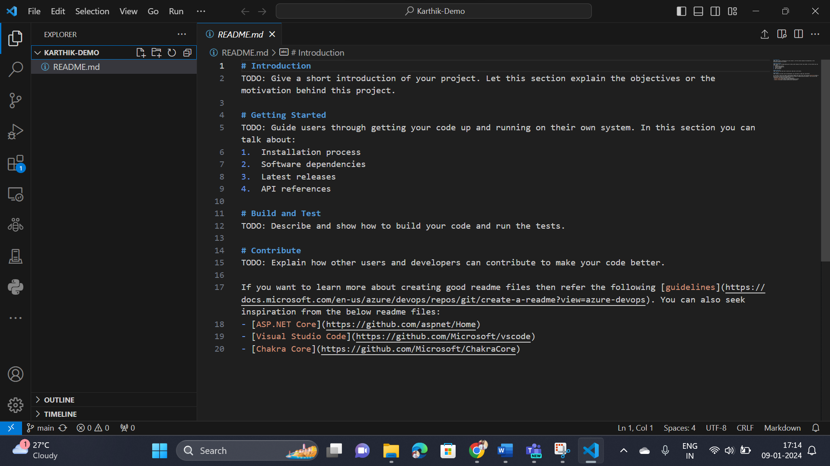

**Step-9:** Create a new file in vs code studio

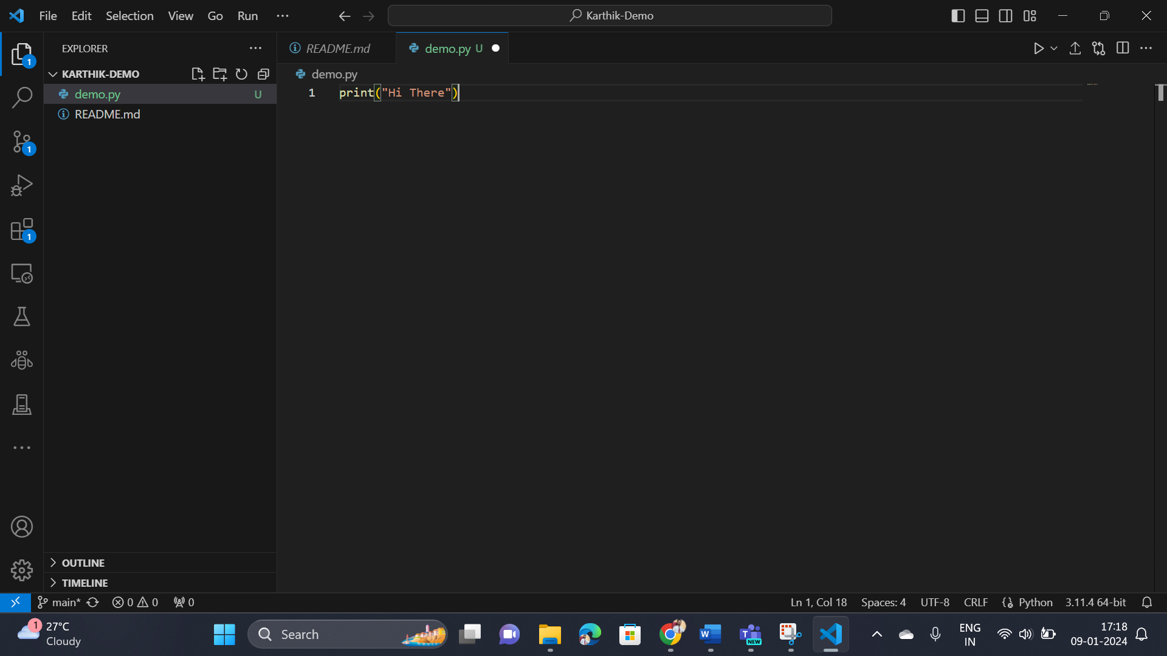

**Step-10:** Open git bash and enter the commands (on repository location).

1. git add demo.py
2. git commit -a -m “my first commit”
3. git push

**Step-11:** Now check the history in Azure DevOps Organization

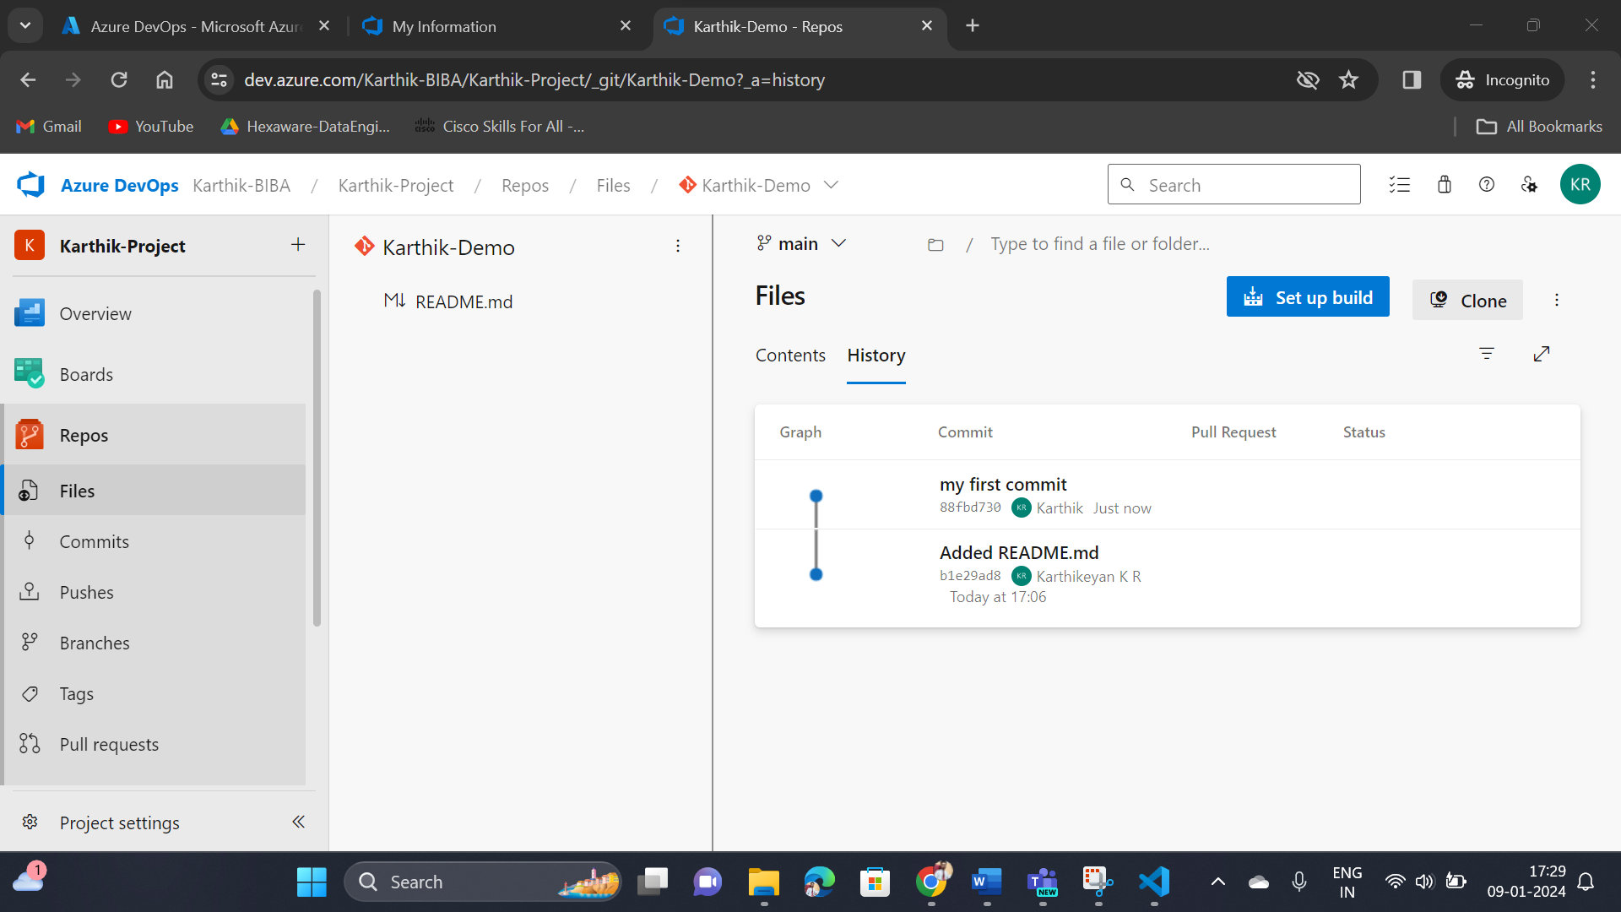

**Step-12:** Once completed, As I don’t need the organization for further so I have deleted the Organization

